- Software as Product
  - Fixed costs: when producing software products, the first copy is very expensive (development cost can be seen as the fixed costs)
  - Variable costs (=marginal costs) of every additional copy are almost zero. E.g. Software CD, where every copy of the software costs as much as a blank CD
  - Exception
    - When SW has to be customized or needs special training
- Software as a Service (Nitu. 2009)
  - is a software delivery paradigm where the software is hosted off-premise and delivered via web and the mode of payment follows a subscription model.
  - In a SW service business (e.g. user interface design services), your employees are the ones to produce the service. So every time you offer a “copy” of your service.
***************************************************************
A number of the factors affect the selection of a particular business model for a given enterprise. Some of them are external market conditions and some of them maybe embedded in business model. Different business models can be viable for situations within the constraints set by the following factors.
- The market environment including competitors, innovation diffusion, network effects, dominant platforms, legal aspects, political values of customers, etc. strongly affects the business models of a software venture.
• Industry competition and infrastructural competition(ASP, ISP, HSP )
***************************************************************
Understanding customer’s – Situation – Utilities – Preferences
• Software vendor must understand the use value of the software as a key element of the business model.
• The customers in each phase of the evolution of the product are fundamentally different
************************************************************************************************
Resource environment: Network effects
– Critical mass of users
– Positive (e.g. wider markets) and negative (e.g. lock-in)
*********************************************************
- The financing environment of a software business can be seen as a combination of the utility functions of its various stakeholders.
- Most commonly used strategies to finance the growth of a software business:
1. Revenue from product sales; 2. Active use of venture capital
*******************************************************************************
The business model of a software company is an action plan derived from strategy to realize the strategic objectives of a company with a given product or service offering in a given market. A single business models is dealing with a single product situation. A business model is described as a combination of different function models of product development, revenue, sales, marketing, servicing and implementation.
The authors compile these structural views of business models into one which includes four elements: Product development approach, Revenue logic; Marketing & sales approach; servicing and implementation approach. The four elements will be described in detail in the following slides. A software company has multiple options to structure each of the elements in its business model.
Product development model:
Product development model defines how the process that creates the value
proposition is structured, I.e. what elements it comprises of and which actors provide them. Our product development model is restricted to the development of a core product, includes the following options:
Product has certain functionality for the end user and developed before the sale with the quality both in conformance and performance.
Plausible Promise: Microsoft's strategy as "revolving around identifying mass markets, quickly introducing products that are 'good enough', improving these products by incrementally evolving their features, and then selling multiple product versions and upgrades to customers around the world."
Parameterised Product is a parameterized product as a software product that cannot be used as such, but must be tailored for a specific customer by setting a number of parameters in the software. Good examples are many ERP-suites.
- Product platform: Set of subsystems and interfaces that form a common structure from which a stream of derivative products can be efficiently developed and produced.
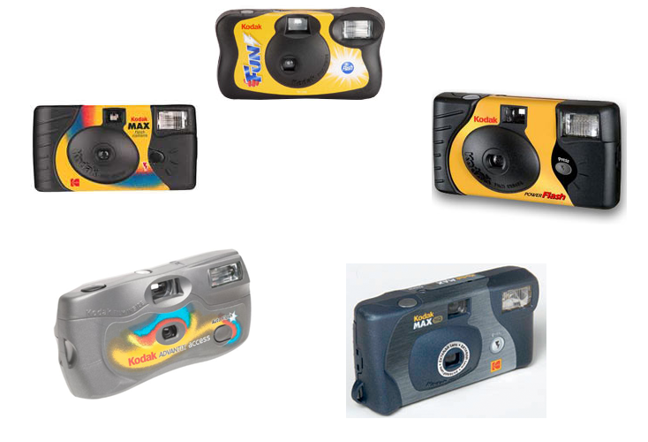 Project:

Revenue logic: Our revenue model element describes how the sales value of the product or service offering is captured by a software venture. Revenue models can be both direct and indirect. In direct models revenue is collected from the user of the software, in indirect model revenue is collected from a third party.

Options to Capture Sales Value:
Licensing: It involves selling the customer the right to use the software.;
Profit sharing : software provider's revenue is tied to its customer's
performance when using the software;
Loss leader: the software is provided for free, but revenue is collected from the same or a related set of buyers by selling related products or services;
Media model;
Hybrid ;
Variable pricing strategies

